- FUNCTION OF PRINTERS, SCANNERS, WEBCAMS, AND THEIR CONNECTION INTERFACES.
Q1. Create a table listing 3 types of printers, 2 types of scanners, and 2 types of webcams, and for each, write one real-life use case (for example: 'Inkjet printer – printing college assignments').
ANS.
Device Category | Type | Real-Life Use Case
Printer | Inkjet Printer | Printing college assignments and photos
Printer | Laser Printer | Printing office reports and business documents
Printer | Dot Matrix Printer | Printing invoices and receipts with carbon copies
Scanner | Flatbed Scanner | Scanning photographs and important documents
Scanner | Handheld Scanner | Scanning barcodes and documents in warehouses or stores
Webcam | Built-in Webcam | Attending online classes or video meetings
Webcam | External USB Webcam | Live streaming or making high-quality video calls

Q2. Draw a labelled diagram showing how a typical home printer connects to a laptop or PC, including the connection interface used (USB, Wi-Fi, or Bluetooth).
ANS.
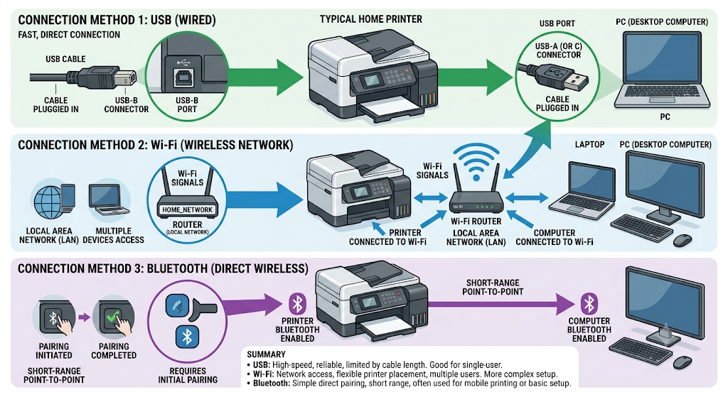

- Summary
- USB: High-speed, reliable, limited by cable length. Good for single-user.
- Wi-Fi: Network access, flexible printer placement, multiple users. More complex setup.
- Bluetooth: Simple direct pairing, short range, often used for mobile printing or basic setup

Q3. List three different connection interfaces (such as USB, Wi-Fi, Bluetooth) used by peripherals like printers, scanners, and webcams, and for each, name one advantage and one disadvantage. Hint Think about speed, convenience, and compatibility.
ANS.
Connection Interface | Used By | Advantage | Disadvantage
USB | Printers, scanners, webcams | Fast and stable connection with high data transfer speed | Requires a cable, limiting movement and distance
Wi-Fi | Printers, scanners,  webcams | Wireless connection allows multiple devices to connect from anywhere on the same network | Can be slower or interrupted if the Wi-Fi signal is weak
Bluetooth | Printers, scanners, webcams | No cables required and easy to connect over short distances | Short range and generally slower than USB

Q4. Pick any one device you use at home or college (printer, scanner, or webcam). Write step-by-step instructions for how you would connect it to your computer, including what cable or wireless method you would use and any setup steps required.
ANS.
- Connecting a Wi-Fi Webcam to a Computer
- Device: Wi-Fi Webcam
- Steps to Connect the Webcam
- Place the Wi-Fi webcam near a power outlet and connect it to the power adapter.
- Turn on the webcam and wait for it to start.
- Download and install the webcam manufacturer's app or software on your computer.
- Open the app and follow the on-screen instructions to connect the webcam to your Wi-Fi network.
- Make sure your computer is connected to the same Wi-Fi network as the webcam.
- Wait for the software to detect the webcam automatically.
- Open a video conferencing application such as Zoom, Microsoft Teams, or Google Meet.
- In the application's Camera Settings, select the Wi-Fi Webcam as the video source.
- Check that the video is displayed correctly and adjust the camera angle if needed.
Connection Method Used: Wi-Fi (Wireless)

